**Final Exam**

**Student Name: Sanghyuk Lee**

**Student Number: 129405171**

**Course: UNX510NSA**

**Professor: Shahdad Shariatmadari**

Answer the following questions by developing some scripts in Matrix.

**Question 1)** Complete the following steps and save them into a script (name it as Q1_yourname.sh) (25 marks)

A. Create an associative array (name it myCourses) which stores your current courses in this semester (more than three courses)

like ULI101: Intro to Unix

B. Display all the array data (both course code and course name

C. Display the size of the array

D. Display size of each course_name

**Following is my code:**

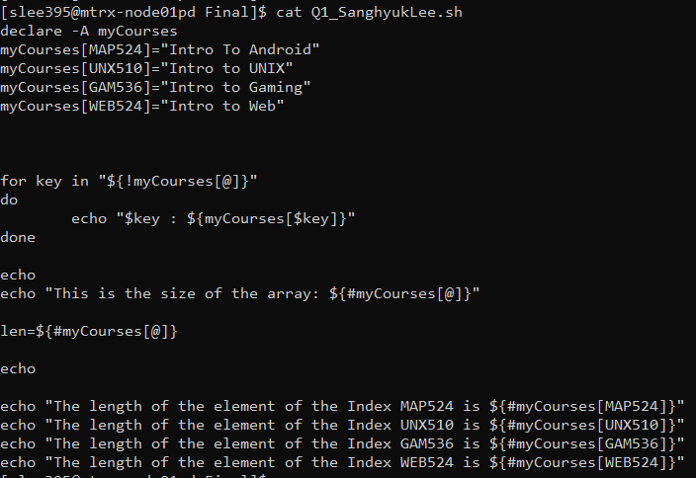

**Demonstration)**

**Answer A)** As you can see in the above picture, I declared an associative array, myCourses and assign the string value in each course.

**Answer B)** The for loop is used to display the following output:

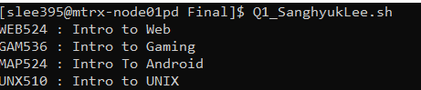

**Answer C)** I used ${#myCourses[@]} to get the size of the array and the output is the following:



**Answer D)** To display the size of each element, I put the string index in the syntax of ${#array[@]} so that I could display the following output:

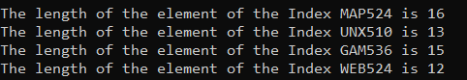

Following is the entire output when I implement the Q1_SanghyukLee.sh

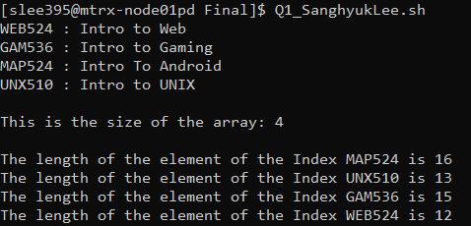

**Question 2)** Your are asked to extract some network information (netmask and broadcast address) from ifconfig command: (35 marks)

You decided to create a script, name it netgear_yourname.sh which works as follow:

netgear_yourname.sh -n -----> it displays all "netmask" addresses

netgear_yourname.sh -b -----> it displays all "broadcast" addresses

Develop this script and consider the following features in your design,

1) You can use any of the filtering commands (sed, awk, grep,...), to extract "netmask" and "broadcast" addresses

2) Use modular programming approach by developing function/procedure

**Ifconfig output the following: we need to get yellow highlighted addresses and red underlined addresses**

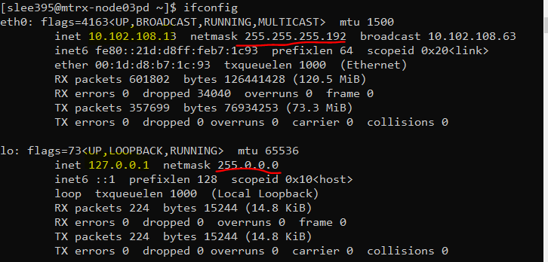



**Following is my code:**

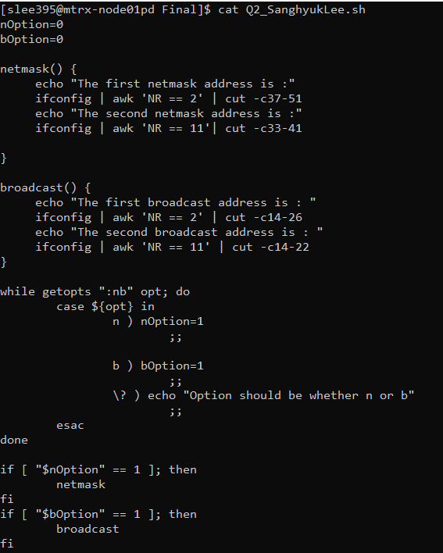

**Demonstration)** I used getopts to get option to use inside case statement. When user provide option -n then it sets the value of variable nOption to 1, for option -b, it sets the value of variable bOption to 1. With those assigned value it implements the appropriate if statement below which directs to the function above. For netmask procedure, it ifconfig first and pipe the awk command to get the proper line and cut the character to get what the question ask. Same logic for the procedure broadcast() is used. When user provide option other than -n and -b, it echoes the error message using the case ‘\?’

**Output:**

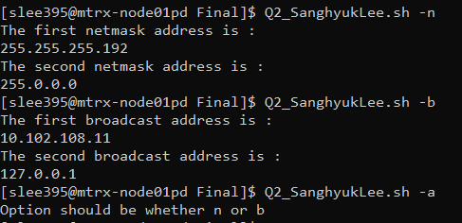

Submission:

1) Make sure to submit a MS-Word file which contains all answers/scripts and screen shots .

2) Make sure to run the following commands once you want to submit your test:

history | tail -1000 > yourname.exam

sendmail shahdad.shariatmadari@senecacollege.ca < yourname.exam